Context

Early March I had decided to take a week off from work. Little did I know that the very next Monday, I would return to an empty office. The premises had been vacated in the wake of a proliferating pandemic.

The reality of covid-19 really struck me and sunk in when I heard of there being more than 600 deaths in a day in New York due to covid-19.

Given the current reporting and the on and off reports of a resurgence, and the various waves of the crises, I decided to compare the numbers between America and India.

As a current resident of the mid-atlantic, with family in asia, this is my way of showing my concern.

The Data

Our data comes from the ‘Our World in Data’ covid tracker website. All data is aggregate, and code is open source. Variables’ measurement are open to probing, and government’s self reported numbers are open to question. Moreover, the US’s superior equipment and capital is likely to show a larger number of cases reported, whereas as India’s underpowered over-burdened hospitals are likely to underreport cases. However, the numbers below compare and contrast the total deaths and cases, and scrutinize the rates of increase.

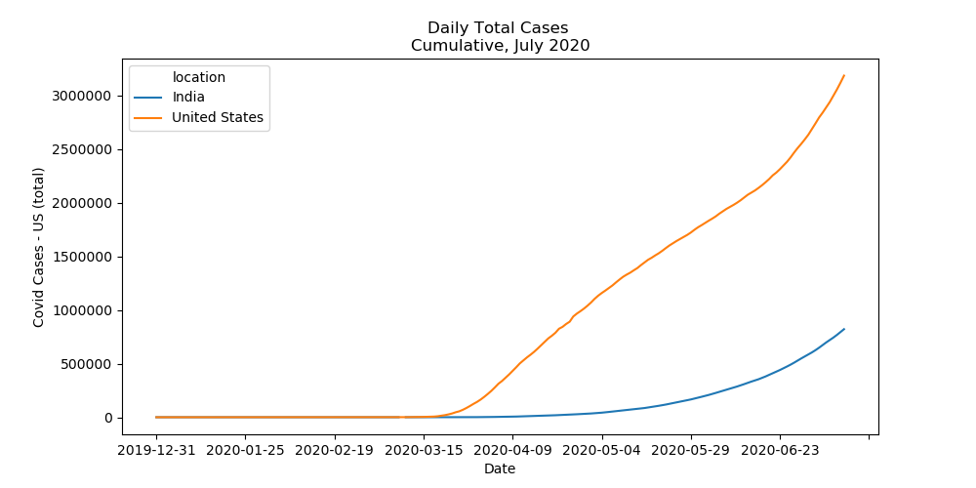

Commentary

What we see here really is a sharp divergence in the total number of covid cases from the middle of march onwards. The above graph shows an increasing number of cases both in America and India, with cases in both countries increasing at an increasing rate. The US’s numbers are far higher than those of India. There is some speculation as to how and why India has managed to keep it’s covid numbers down. However, in recent days, we have found the number of deaths to be increasing at an increasing rate, as shown below.

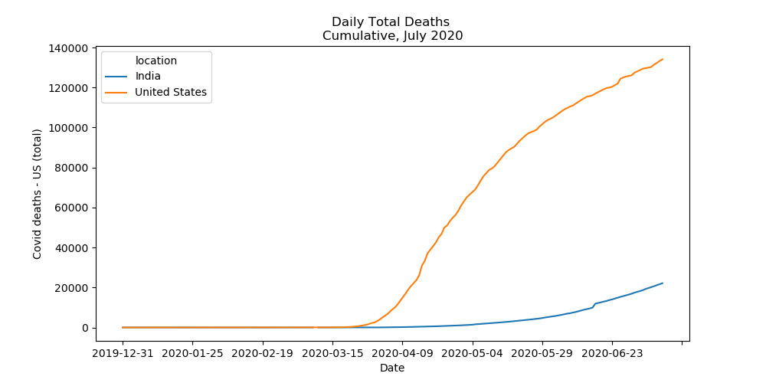

While the US’s growth in number of deaths is tapering off, that of India’s is seeing a sudden increase. Below, the daily % change in the number of deaths resulting from the disease shows that for the last two weeks, India’s death count has been increasing by 2,000% daily, whereas that of the US has been increasing by less than 500% per day.

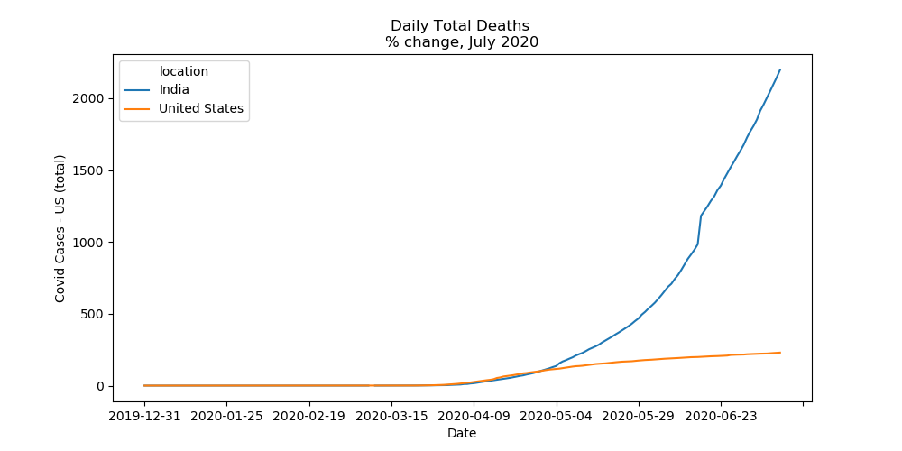

Whether or not this is owing to the fact that the US has much larger absolute numbers, and is therefore increasing at a decreasing pace is besides the question. A slowing increase is the type of sign we wish to see in curbing this disease.

Conclusion

With Modi having assumed office in 2019 for a second term, and Trump up for an election in 2020, the US economy is going to see some major disruptions. While the US is far better equipped to be dealing with distributed service jobs, and is taking measures to maintain its supply chains in the face of risk, India’s brick and mortar based economy is sure to take a harder hit in the near term.

Nonetheless, there have been reports of the occasion being a relief and breather for the Indian environment. We hope that in the next few weeks, we’ll see a dampening of the curve and leveling off of the numbers both in the US, and in India.